Performance Evaluation

CONTENTS

1. CPU Benchmark
2. MEMORY Benchmark
3. DISK Benchmark
4. Existing Benchmarks and Efficiency Computation (Extra Credit)
___________________________________________________________________________________
1. CPU Benchmark:
We are performing a total of 2*3+1*2 = 8 experiments for CPU Benchmark. Following are the observations after executing CPUBenchmark.c on AWS EC2 t2.micro instance in experiment 1:

FLOPS are floating point operations performed per second by the CPU. GFLOPS are the Giga Flops. Similarly IOPS and GIOPS are Integer operations per second and Giga IOPS respectively. Let's plot these observations as Giga Operations performed on X-AXIS and No. of threads on Y-AXIS. After plotting these observations on graph, we observed following curves:
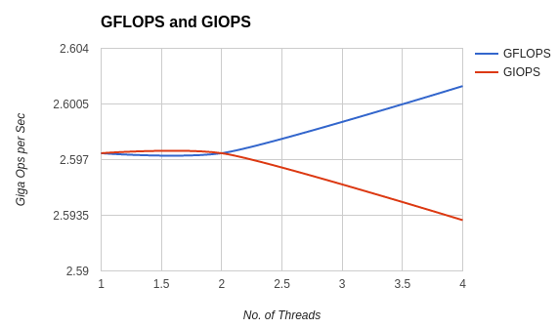

Analysis : Above chart clearly shows performance gain when number of threads were increased from 1 to 2 for both GIOPS and GFLOPS. However, when threads were increased from 2 to 4, GFLOPS were reduced. Also, GFLOPS are always lesser than GIOPS. This shows, floating point instructions take more time to execute than Integer. On the other hand, GIOPS were increased when threads were increased from 2 to 4.
The other experiments include samples on 600 Seconds i.e. 10 minutes IOPS and 10 minutes FLOPS. Following is the graph obtained by plotting 600 GIOPS and GFLOPS on Y-Axis and Time on X-Axis:
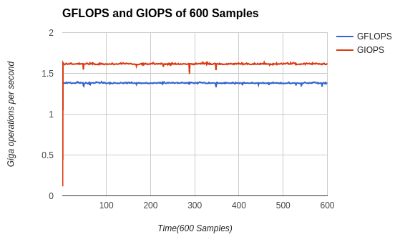
The above graph is nearly a straight line. Still we can see some ups and downs on the line as CPU performance is not constant throughout the 600 seconds.
Theoretical Performance:
Formula for FLOPS: Sockets ×(cores÷socket)×clocks ×(flops÷cycle)
As AWS EC2 t2.micro instance is a single core single processor, we will use following data:

Socket =1, Cores = 1, Clocks = 2.20 GHz and Flops/cycle = 4

Theoretical peak CPU FLOPS = 2.20 * 4
= 8.8 Giga FLOPS

2. MEMORY Benchmark:
We performed 1*2*3*2 = 12 experiments for Memory Benchmark. Following are the observations after executing MEMORYBenchmark.c on AWS EC2 t2.micro instance in experiment 1:

After plotting these observations of throughout and latency we can see following graphs:
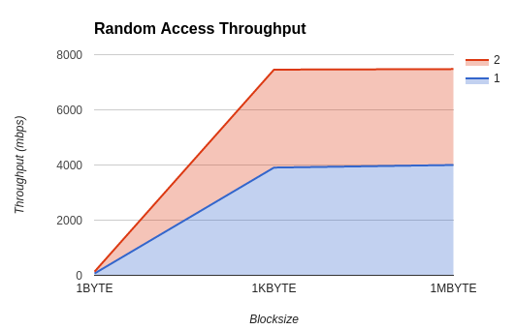

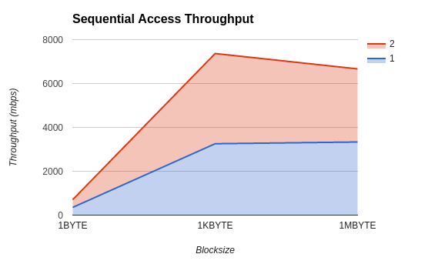

As we can see, throughout is increased with number of threads and gives higher performance with increased Blocksize. This is because, as the block size is increased, more data is transferred per instruction. And when one thread is reading other can finish the writing. Hence, more throughout is achieved.
Below are graphs of latency plotted for random and sequential read+write. The latency is plotted on Y-axis and block size on right side.
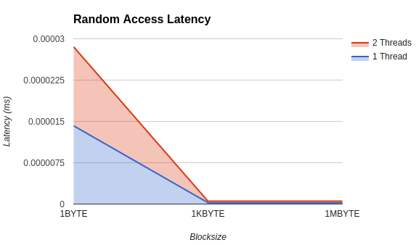

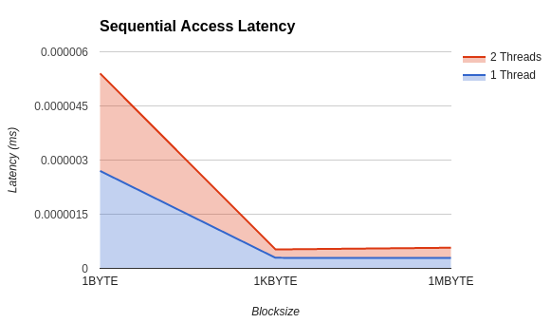

As we can see here, latency of random read+write is much higher than latency of sequential read+write. This is because of time required for overhead of positioning the memory pointer from current location to the given location.

Theoretical Performance:
As Amazon doesn’t give out the clock frequency, assuming the details of AWS EC2 t2.micro instance. using following formula:
Memory bandwidth = (clock speed for RAM) * (number of bits) * (number of lines per clock) * (number of interfaces)
Clock speed for RAM = 1600MHz No. of lines per clock=2
No. of bits for DDR3 = 64 bits No. of interfaces = 2 (dual channel mode)

Theoretical Memory bandwidth = 1600 * 64 * 2 * 2
= 409600 (Mega bits per seconds)
= 51200 (mbps)

3. DISK Benchmark:
We performed 2*2*3*2 = 24 experiments for Disk Benchmark. Following are the observations after executing DISKBenchmark.c on AWS EC2 t2.micro instance:

After plotting graphs of above observations of Write operations, we can compare sequential and random access throughput as given below :
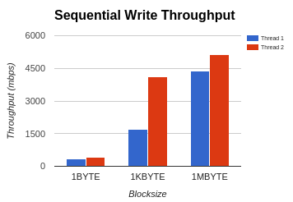
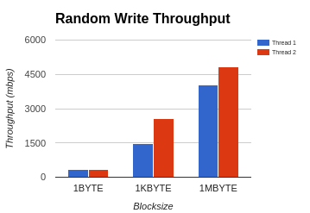

As shown above, 5 of 6 cases gives high throughput in WRITE operations of Sequential Access in comparison to Random Access. This is because of overhead included in moving the disk head to the specified location from current location. Similarly following are graphs of Read operations:
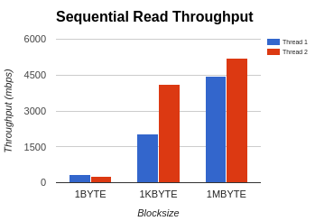
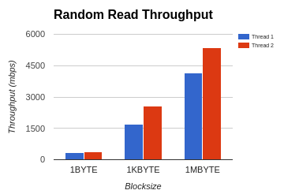
As shown above all the cases gives high throughput in READ operations of Sequential Access in comparison to Random Access. This is because of overhead included in moving the disk head to the specified location from current location.
Following are graphs of latency for Write operations:
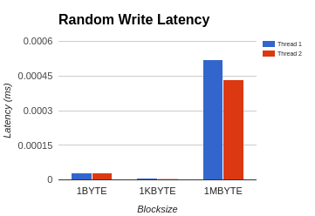
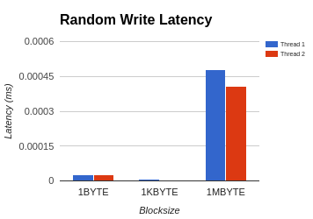

As we can see, Latency for 1BYTE is much higher than Latency for 1KBYTE. However, when blocksize is increased from 1KBYTE to 1MBYTE, Latency is increased. When concurrency comes in pictue, DISK performance is reduced unlike CPU or MEMORY.
Following is the graph for Random Access and Sequential Access Latency for READ operations:

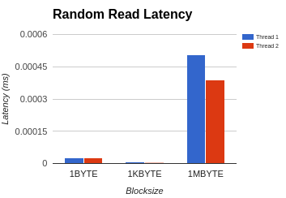
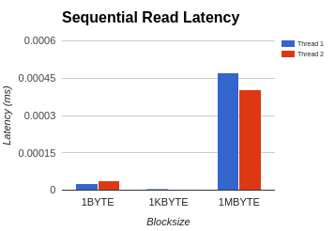
Observations:
- As block size increases, Throughput also increases
- Increased number of threads slightly increases performance
- Sequential access has higher throughout in comparison with random access
- Write operation has higher latency and lesser throughout as compared to that of Read operations.
Analysis:
- Positioning of Disk platter head hampers the DISK performance
- Concurrency adds up in DISK Performance
- Blocksize per instruction does a proportional improvement on DISK Performance
- Writing to disk takes more time than reading from a disk. This can be due to 2 possibilities. Either the data to read is already present on the
Theoretical Performance:
Theoretical DISK speed of Amazon EC2 t2.micro instance : 6GBPS

4. Comparison with existing benchmarks (Extra Credit):
1. CPU Benchmark vs Linpack:
Following are the Linpack outputs after executed on AWS EC2 instance:
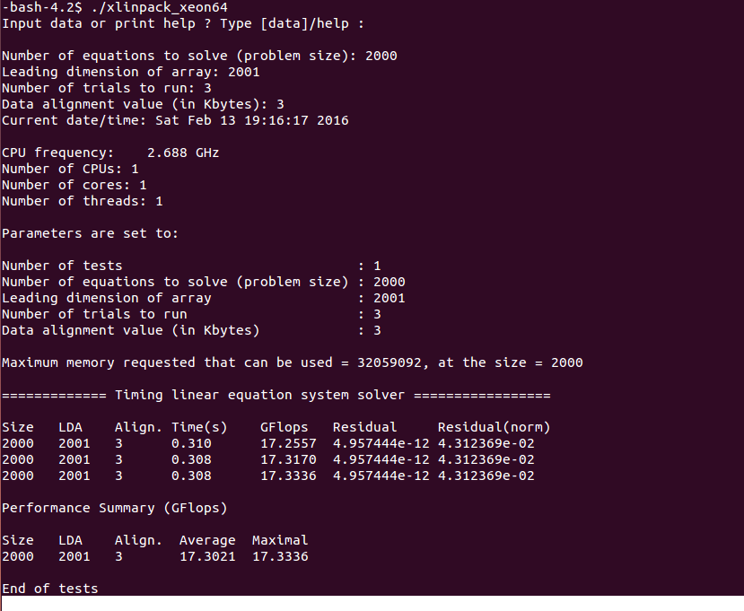
As per the results, Best readings are: 17GFLOPS
Theoretical CPU performance: = 8.8 Giga FLOPS
Best result of CPUBenchmark.c: ~ 2.6 GFLOPS
Efficiency achieved: ~30%
2. MEMORY Benchmark(Stream)
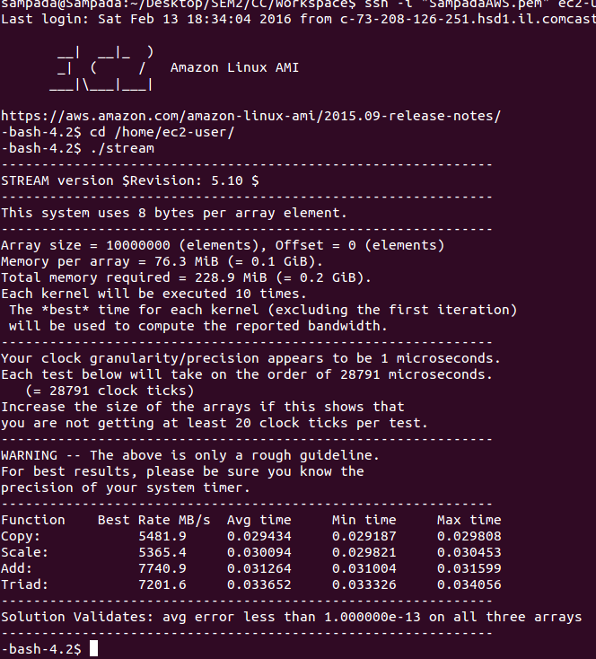

As per the results, Best readings are: 5481 Mbps
Theoretical MEMORY performance = 51200 (mbps)
Best result of MEMORYBenchmark.c: ~4111(mbps)
Efficiency achieved: ~8%

3. DISK Benchmark (iozone)
READ
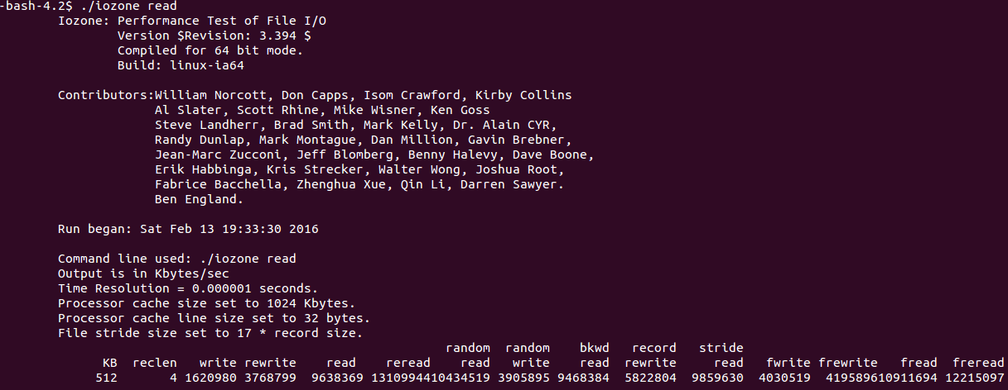
Random READ
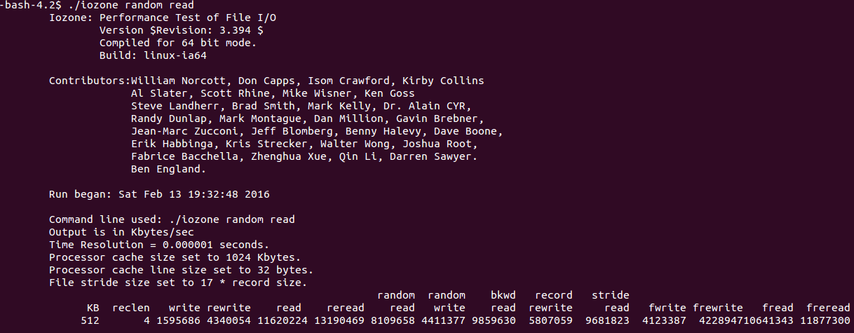
WRITE
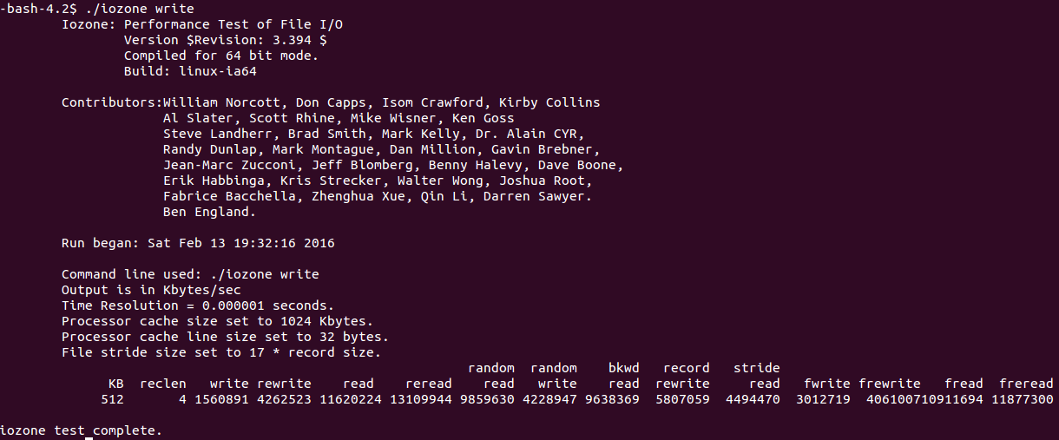
Random WRITE
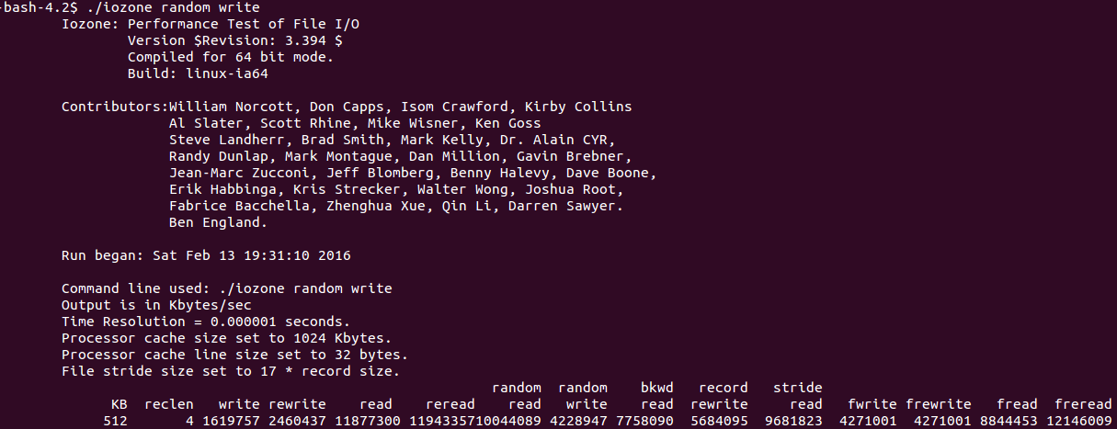
As per the results, Best readings are: 4-5 Gbps
Theoretical DISK performance = 6 (gbps)
Best result of DISKBenchmark.c: ~4(gbps)
Efficiency achieved: ~66%

